富怡喷墨绘图中心软件使用说明书
RICHPEACE Inkjet Drawing Center Software User Manual

目录（Table of Contents）

1 产品介绍（Product Introduction） 3
2软件安装与联机（Software installation and online connection） 3
2.1软件安装（Software installation） 3
2.2 USB方式联机（Connect via USB） 4
2.3 绘图仪的IP设置（The IP Settings of the plotter） 5
2.4 网线方式联机（直连）Online via network cable (direct connection) 5
2.5 网线方式联机（通过交换机、路由器）Network cable connection (via switch, router) 6
2.5.1 电脑IP设置为静态IP的方法（The method of setting the computer IP to a static IP） 7
2.5.2 电脑IP设置为自动获取IP的方法（The method of setting the computer IP to automatically obtain the IP） 7
3 软件主界面（Software main interface） 9
3.1 菜单栏（Menu bar） 10
3.2 控制面板（Control panel） 10
3.3 工作列表（Work list） 13
3.4 图样预览区（Pattern preview area） 13
3.5 状态栏（Status bar） 13
4 绘图单位（Drawing unit） 13
5 系统设置（System Settings） 14
5.1 绘图设置（Drawing Settings） 14
5.2 目录设置（Directory Settings） 16
5.3 用户设置（User Settings） 17
6 机器设置（Machine Settings） 18
6.1 喷头设置（Nozzle setting） 19
6.2 边线调整（Edge line adjustment） 19
6.3 机械参数（Mechanical parameters） 19
6.4 裁断功能（Discretion function） 20

1 产品介绍
喷墨绘图中心是一款用于管理喷墨服装绘图仪的软件。软件支持WinXP，Win7，Win8.1，Win10等操作系统，兼容性强。软件能够对各种CAD制版软件输出的plt或dxf文件进行读取，并进行旋转，分页，镜像，合并等处理，并可将处理后的文件以plt文件的形式导出。能够管理绘图仪的校正参数，并且还能够对打印列表和参数进行保存，使用方便快捷。
Inkjet Drawing Center is a software used for managing inkjet garment plotters. The software supports operating systems such as Windows XP, Windows 7, Windows 8.1, and Windows 10, and has strong compatibility. The software is capable of reading plt or dxf files output by various CAD plate-making software, and performing operations such as rotation, pagination, mirroring, and merging. It can also export the processed files in the form of plt files. It can manage the calibration parameters of the plotter, and also save the print list and parameters. It is convenient and fast to use.

2软件安装与联机（Software installation and online connection）

2.1软件安装（Software installation）
喷墨绘图管理软件为绿色免安装软件,只需要解压缩,然后发送到桌面即可.
The inkjet drawing management software is a green and no-installation software. You only need to extract it and then send it to the desktop.
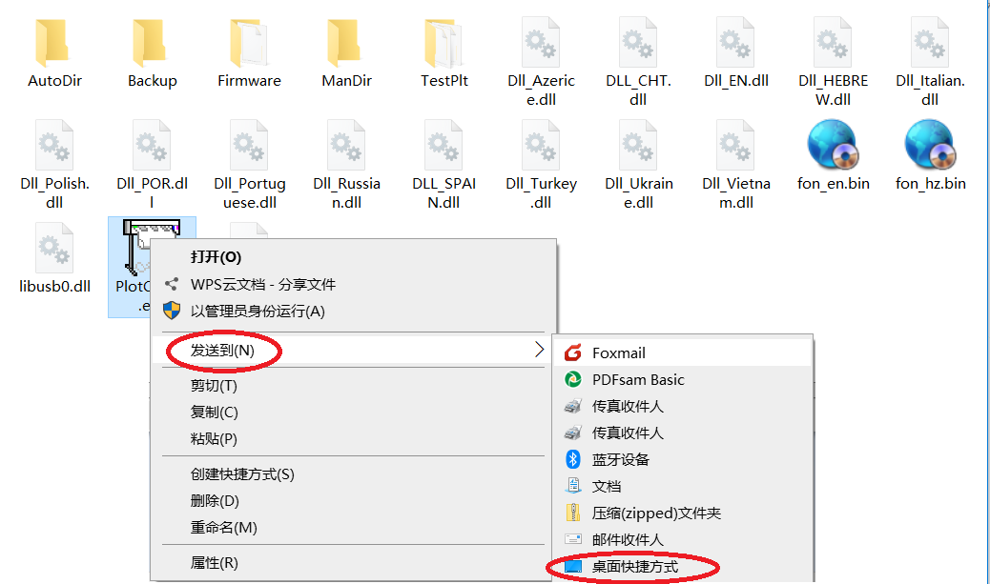
（图2.1）

2.2 USB方式联机（Connect via USB）
使用USB打印线，一头插入装有本软件的电脑，另外一头插入绘图仪主板上的USB接口中，然后开机。
此时，如果电脑出现发现USB设备的提示音，就证明USB联机成功。
Use a USB printing cable. Insert one end into the computer with this software installed and the other end into the USB port on the plotter's motherboard. Then turn on the computer.
At this point, if the computer emits a prompt sound indicating that the USB device has been detected, it indicates that the USB connection has been successful.
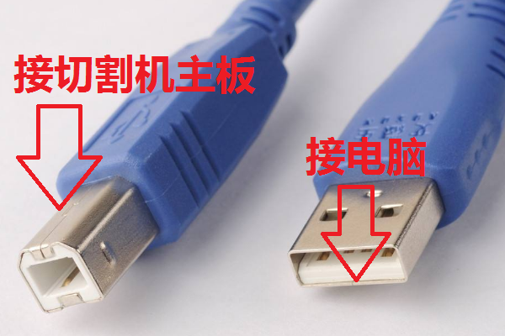
（图2.2）

2.3 网线方式联机（直连）（Online via network cable (direct connection)
网线联机可以采用直连的方式（如图2.3所示）。需要注意的是，采用直连方式，如果电脑的网口不支持自动极性翻转功能，则联机的网线必须使用交叉网线才行，也就是网线的两头线序排列，一头采用586A标准，一头采用586B标准（如需了解，请使用搜索引擎上网进行了解）。
Network cable connection can be achieved through direct connection (as shown in Figure 2.3). It should be noted that when using the direct connection method, if the network port of the computer does not support the automatic polarity reversal function, the network cable used for connection must be a crossover cable. That is, the two ends of the network cable should be arranged in sequence, with one end using the 586A standard and the other end using the 586B standard (for more information, please use a search engine to access the Internet).
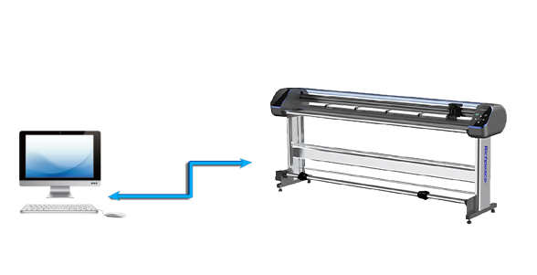
（图2.3）（(Figure 2.3)
采用直连方式时，
电脑IP应该设置为静态IP，192.168.1.100，
子网掩码设置为255.255.255.0，
网关IP设置为192.168.1.1，
绘图仪IP不用修改，采用默认的192.168.1.175即可。
When the direct connection method is adopted,
The computer IP should be set to a static IP, 192.168.1.100.
The subnet mask is set to 255.255.255.0.
The gateway IP is set to 192.168.1.1.
The IP of the plotter does not need to be modified. Just use the default 192.168.1.175.

2.4 网线方式联机（通过交换机、路由器）（Network cable connection (via switch, router)
网线联机也可采用电脑和绘图仪共同连接在一个交换机（或路由器）的方式（如图2.4所示），采用这种方式联机的好处是可以多台电脑控制一台绘图仪。
通过交换机、路由器联机时，电脑的IP可采用设置静态IP的方法，也可以设置为自动获取（前提是所连接的路由器开启了自动分配IP的功能）。Network cable connection can also be achieved by connecting a computer and a plotter to a single switch (or router) (as shown in Figure 2.4). The advantage of this connection method is that multiple computers can control one plotter.
When connecting through a switch or router, the computer's IP address can be set to a static IP address or automatically obtained (provided that the connected router has enabled the automatic IP allocation function).
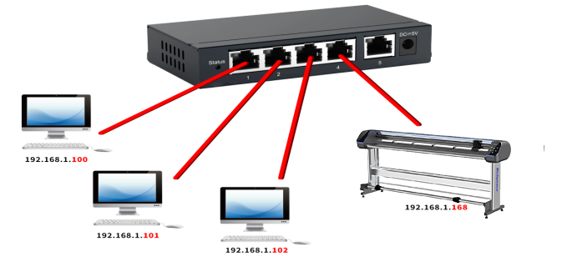
（图2.4）

2.4.1 电脑IP设置为静态IP的方法（The method of setting the computer IP to a static IP）
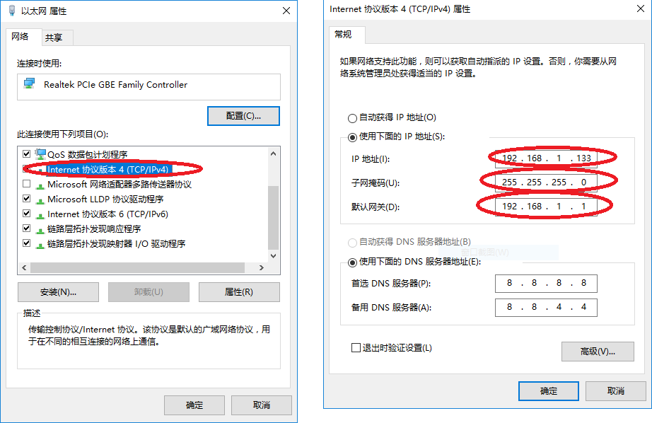
（图2.5设置静态IP的方法）（(Figure 2.5 Method for Setting Static IP)
其中，子网掩码一般设置为255.255.255.0，表示内网支持255台电脑在同一C类网段。（如果您了解TCP/IP协议，子网掩码当然也可以按照需要设置成其他的，不在此赘述了）。默认网关一般设置为前三段和IP一样，最后一段设置成1或255（与具体路由设置有关，如果不需要访问外网，也可以空出不填）。
如图2.8所示，电脑之间，以及电脑和绘图仪之间，蓝色部分IP字段应保持一样，红色字段不能一样。

Among them, the subnet mask is generally set to 255.255.255.0, indicating that the internal network supports 255 computers in the same Class C network segment. If you are familiar with the TCP/IP protocol, the subnet mask can of course be set to other Settings as needed, which will not be elaborated here. The default gateway is generally set to have the first three segments the same as the IP, and the last segment set to 1 or 255 (depending on the specific routing Settings. If you do not need to access the external network, you can also leave it blank).
As shown in Figure 2.8, between computers and between computers and plotters, the blue IP fields should remain the same, and the red fields cannot be the same.

例如
电脑A可以设置为192.168.3.123，
电脑B设置为192.168.3.134
电脑C设置为192.168.3.136
。。。
打印机的IP设置为192.168.3.175
For example
Computer A can be set to 192.168.3.123.
Computer B is set to 192.168.3.134
The computer C is set to 192.168.3.136
...
The IP of the printer is set to 192.168.3.175
例如
电脑A可以设置为100.160.1.123，
电脑B设置为100.160.1.134
电脑C设置为100.160.1.136
。。。
打印机的IP设置为100.160.1.175
For example
Computer A can be set to 100.160.1.123.
Computer B is set to 100.160.1.134
The computer C is set to 100.160.1.136
...
The IP setting of the printer is 100.160.1.175
。。。

2.4.2 电脑IP设置为自动获取IP的方法（The method of setting the computer IP to automatically obtain the IP）
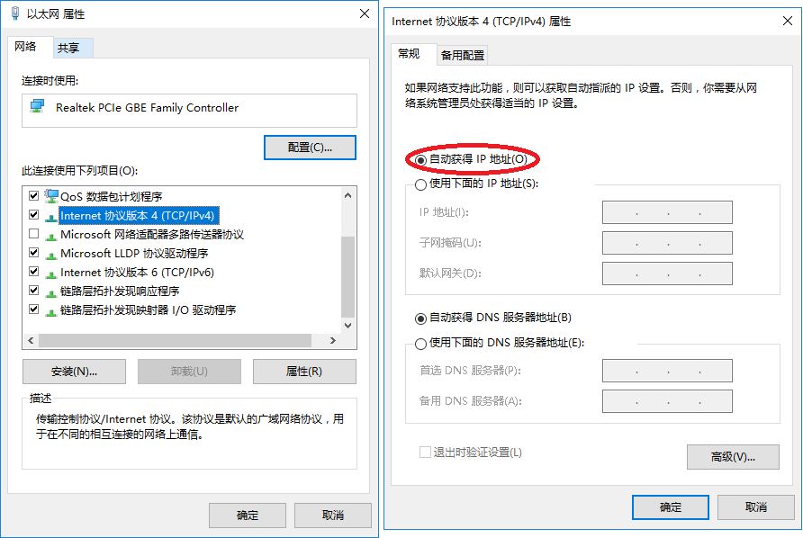
（图2.6设置自动获取IP的方法）（(Figure 2.6 Method for Setting up automatic IP Acquisition)
如果电脑设置为自动获取IP的方式，则需要查看电脑的IP是多少，可以有两种方式，一种是打开cmd，在里面输入ipconfig /all指令，If the computer is set to automatically obtain IP addresses, it is necessary to check the IP address of the computer. There are two ways to do this. One is to open cmd and enter the "ipconfig /all" command inside.
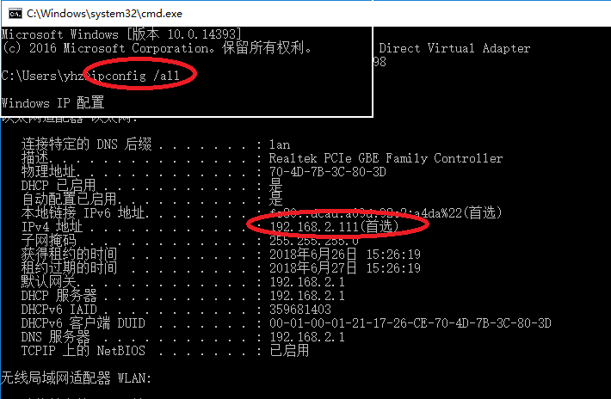
（图2.7 查看本地IP方法1）(Figure 2.7 View Local IP Method 1)
另外一种方法如图2.8所示Another method is shown in Figure 2.8
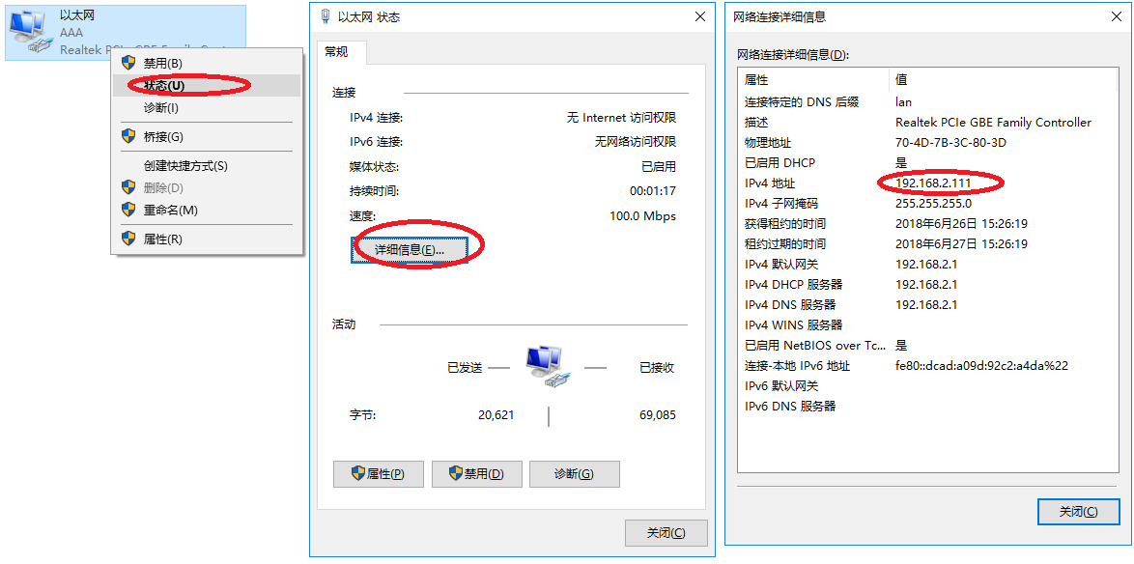
（图2.8）
此时，按照电脑IP前3段和绘图仪IP前3段相同，第4段不同的原则，将绘图仪的IP改为192.168.2.x （x不能等于111，也不能和插在路由器上的其他电脑的IP的第4段相同）即可。
设置完成后在联机的情况下选择联机方式为网口，然后关闭输出中心，将机器重启后即会自动连接。At this point, following the principle that the first three segments of the computer's IP are the same as those of the plotter's IP, but the fourth segment is different, change the plotter's IP to 192.168.2.x (x cannot be equal to 111, nor can it be the same as the fourth segment of the IP of other computers plugged into the router).
After the Settings are completed, when the machine is online, select the online mode as network port, then close the output center. After restarting the machine, it will automatically connect.

3 软件主界面（Software main interface）
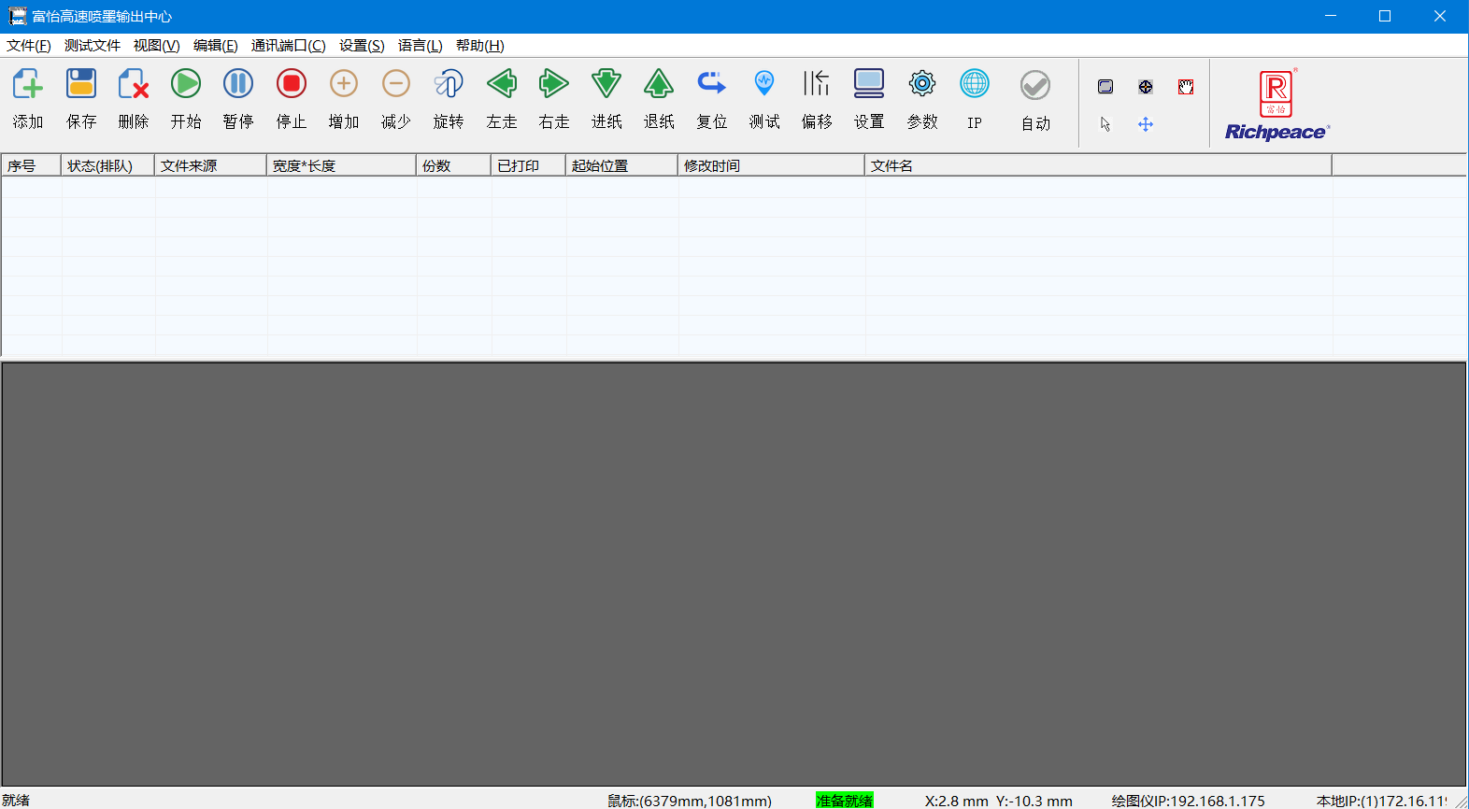
（图3.1）(Figure 3.1)
软件主界面如图3.1所示。（The main interface of the software is shown in Figure 3.1.）
1 菜单栏（Menu bar）
2 工具栏（Toolbar）
3 工作列表（Work list）
4 图样预览区（Pattern preview area）
5 状态栏（Status bar）
下面就每个部分进行说明。The following is an explanation of each part.

3.1 菜单栏Menu bar
主菜单Main menu | 子菜单Submenu | 子菜单 | 说明Explanation
文件File | 打开Open |  | 用于打开文件并添加到工作列表。Used to open files and add them to the work list.
文件File | 保存Save |  | 将选定的页面保存为一个plt文件。Save the selected page as a plt file.
文件File | 退出Exit |  | 关闭本软件。Close this software.
视图View | 控制面板Control panel |  | 用于展示/隐藏控制面板。Used for showing/hiding the control panel.
视图View | 适合窗口Suitable for Windows
视图View | 隐藏Hide |  | 将软件窗体隐藏到系统任务栏。（软件进入后台运行）Hide the software form to the system taskbar. (The software runs in the background.
编辑Editor | 撤销"Revoke" |  | 用于撤消用户最近一次的操作。Used to undo the user's most recent operation.
编辑Editor | 重做Redo |  | 用于用户进行撤销操作以后，恢复被撤销的操作。It is used to restore the revoked operation after the user performs the undo operation.
通讯端口Communication port | 网口Network port |  | 设置本软件连接机器的方式为网线Set the way this software connects to the machine to a network cable
通讯端口Communication port | 免驱USB（USB打印支持）Driver-free USB (USB printing support) |  | 设置本软件连接机器的方式为USBSet the way this software connects to the machine to USB
设置Settings | 绘图单位Drawing unit |  | 详见4 绘图单位For details, please refer to 4 drawing units
设置Settings | 系统设置System Settings |  | 详见5 系统设置For details, please refer to System Settings 5
设置Settings | 机器参数Machine parameters |  | 详见6 机器参数For details, please refer to 6 Machine Parameters
设置Settings | 注册Register | 主板密码Motherboard password | 进入主板密码设置界面Enter the motherboard password setting interface
设置Settings | 注册Register | 分期密码Installment password | 进入分期密码设置界面Enter the installment password setting interface
语言Language | 简体中文Simplified Chinese |  | 切换主界面显示的语言为中文Switch the language displayed on the main interface to Chinese
语言Language | 英文English |  | 切换主界面显示的语言为英文Switch the language displayed on the main interface to English
语言Language | ... |  | 。。。
帮助Help | 关于About |  | 显示软件版权信息以及版本号Display the software copyright information and version number
帮助Help | 固件升级Firmware upgrade |  | 升级主板固件（需要联系工厂确认才能进行升级操作）Upgrade the motherboard firmware (The upgrade operation can only be carried out after contacting the factory for confirmation)

3.2 控制面板Control panel
按钮Button | 说明Explanation
 | 打开文件并添加到工作列表。（同菜单栏“打开”）Open the file and add it to the work list. (Same as "Open" in the menu bar)
 | 将在工作列表中选中的文件保存为PLT文件。Save the selected files in the work list as PLT files.
 | 将在工作列表中选中的文件移除工作列表。（同菜单栏“删除”）Remove the selected files from the work list. (Same as "Delete" in the menu bar)
 | 如果工作列表中有文件，点击此按钮，绘图仪将开始工作。  如果绘图仪处于暂停状态，绘图仪将恢复以前未完成的工作任务。If there are files in the work list, click this button and the plotter will start working.  If the plotter is in a paused state, the plotter will resume the previously unfinished work tasks.
 | 如果绘图仪处于工作状态，绘图仪将暂停当前的工作任务。If the plotter is in operation, it will suspend the current task.
 | 如果绘图仪处于工作状态，绘图仪将停止当前的工作任务。If the plotter is in operation, it will stop the current task.
 | 增加工作列表中选中任务的打印份数。Increase the number of print copies of the selected tasks in the work list.
 | 减少工作列表中选中任务的打印份数。Reduce the number of print copies of the selected tasks in the work list.
 | 对工作列表选中的任务进行顺时针旋转90度。Rotate the selected task in the work list clockwise by 90 degrees.
 | 按下此按钮时，绘图仪机头会朝着Y+向进行移动。  抬起此按钮时，移动会停止。When this button is pressed, the plotter head will move in the Y+ direction.  When this button is lifted, the movement will stop.
 | 按下此按钮时，绘图仪机头会朝着Y-向进行移动。  抬起此按钮时，移动会停止。When this button is pressed, the plotter head will move in the Y direction.  When this button is lifted, the movement will stop.
 | 按下此按钮时，绘图仪机头会朝着X+向进行移动。  抬起此按钮时，移动会停止。When this button is pressed, the plotter head will move in the X+ direction.  When this button is lifted, the movement will stop.
 | 按下此按钮时，绘图仪机头会朝着X-向进行移动。  抬起此按钮时，移动会停止。When this button is pressed, the plotter head will move in the X- direction.  When this button is lifted, the movement will stop.
 | 控制机器进行复位操作。Control the machine to perform the reset operation.
 | 控制机器打印测试页面。Control the machine to print the test page.
 | 对机器左偏移量进行设置。Set the left offset of the machine.
 | 进行系统设置。（同菜单栏“系统设置”）Set up the system. (Same as "System Settings" in the menu bar)
 | 进行参数设置。（同菜单栏“机器参数”）Set the parameters. (Same as "Machine Parameters" in the menu bar)
 | 进行网络设置，可对绘图仪IP进行参数设置。Network Settings can be made, and parameters of the plotter IP can be set.
 | 为勾选项，勾选时为自动打印模式，任务队列有任务时自动进行打印。未勾选为手动打印模式，任务队列有任务时，需选择任务并点击开始按钮，才能开始打印。This is an option to check. When checked, it is in automatic print mode. When there are tasks in the task queue, it will print automatically. If the manual printing mode is not checked, when there are tasks in the task queue, you need to select the task and click the Start button before you can start printing.
 | 自动识别打印任务图样，并合理放置在预览区域内。Automatically identify and print the task pattern and place it reasonably in the preview area.
 | 可设置图样从何处开始打印，可设定X轴任意位置。The pattern can be set from where to start printing, and any position on the X-axis can be set.
 | 可在图样预览区内移动图样。The pattern can be moved in the pattern preview area.
 | 可在图样预览区内选择线条。Lines can be selected in the pattern preview area.
 | 可在图样预览区内移动线条。The lines can be moved in the preview area of the pattern.

3.3 工作列表（Work list）
用于显示待打印的文件，以及文件的基本信息，包括状态，宽度*长度，分数，起始位置，文件名等。在列表中单击列表项，可进行删除，打印，暂停和调整工作顺序等操作。
It is used to display the file to be printed and the basic information of the file, including status, width * length, score, starting position, file name, etc. Click on a list item in the list to perform operations such as deletion, printing, pausing and adjusting the working sequence.

3.4 图样预览区（Pattern preview area）
图样预览区用于显示列表中任务文件的图样预览。The pattern preview area is used to display the pattern preview of the task files in the list.

3.5 状态栏（Status bar）
显示机器的连接状态；
就绪，表示机器移连接成功，等待执行打印任务。
脱机，表示机器未连接。
显示鼠标在图样预览区的XY轴坐标；
显示绘图仪的工作坐标；
显示绘图仪和控制电脑的网络IP。
Display the connection status of the machine;
"Ready" indicates that the machine has been successfully connected and is waiting to execute the printing task.
"Offline" indicates that the machine is not connected.
Display the Xy-axis coordinates of the mouse in the pattern preview area;
Display the working coordinates of the plotter;
Display the network IP of the plotter and control computer.

4 绘图单位（Drawing unit）
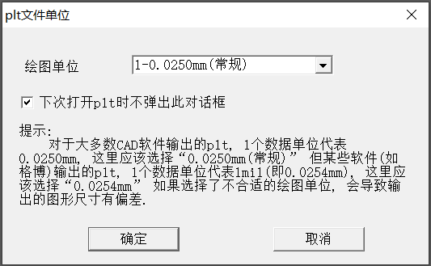

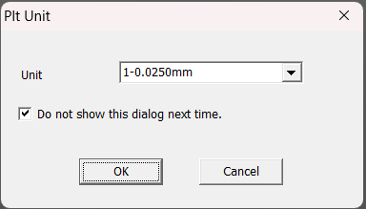

由于对于plt文件一个数据单位实际长度定义的不同，有的一个单位代表0.025mm，有的则代表1mil，即0.0254mm。需要在此进行匹配设置，否则会出现打印尺寸的偏差。

Due to the different definitions of the actual length of a data unit in the plt file, some units represent 0.025mm, while others represent 1mil, that is, 0.0254mm. Matching Settings need to be made here; otherwise, there will be deviations in the print size.

5 系统设置（System Settings）
点击图标或菜单栏选择“系统设置”会弹出系统设置界面。
Clicking the icon or selecting "System Settings" from the menu bar will pop up the system Settings interface.

5.1 绘图设置（Drawing Settings）
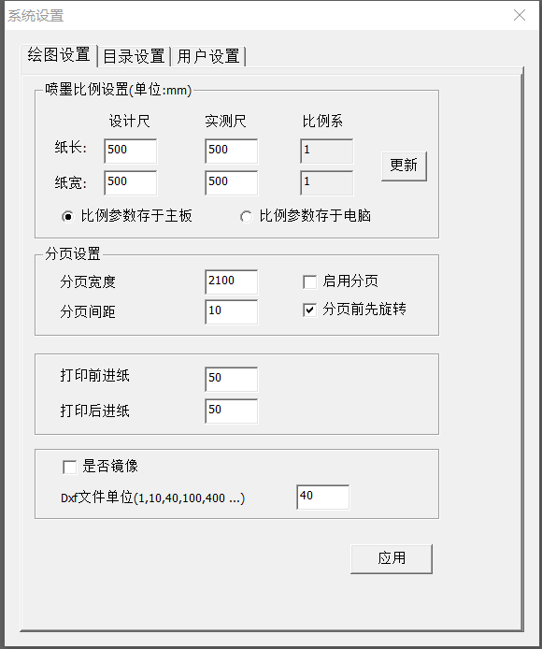

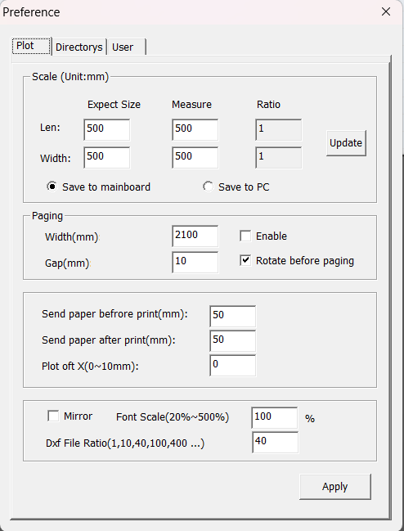

（图5.1）(Figure 5.1)
绘图设置如图5.1所示，具体参数含义如下The drawing Settings are shown in Figure 5.1. The specific parameter meanings are as follows
序号Serial number | 参数名称Parameter name | 含义Meaning
1 | 设计尺寸-纸长Design size - Paper length | 打印文件中设置的图样长度。The length of the pattern set in the print file.
2 | 设计尺寸-纸宽Design size - Paper width | 打印文件中设置的图样宽度。The width of the pattern set in the print file.
3 | 实测尺寸-纸长Measured size - Paper length | 绘图仪打印出的图纸实际测量长度。The actual measured length of the drawing printed by the plotter.
4 | 实测尺寸-纸宽Measured size - Paper width | 绘图仪打印出的图纸实际测量宽度。The actual measured width of the drawing printed by the plotter.
5 | 比例系数-纸长Proportional coefficient - Paper length | 设计尺寸和实测尺寸的比例关系。（无需填写，自动计算）The proportional relationship between the designed dimensions and the measured dimensions. (No need to fill in, automatic calculation)
6 | 比例系数-纸宽Proportional coefficient - Paper width | 设计尺寸和实测尺寸的比例关系。（无需填写，自动计算）The proportional relationship between the designed dimensions and the measured dimensions. (No need to fill in, automatic calculation)
7 | 比例参数存于主板The proportional parameters are stored on the motherboard | 比例参数存于主板上。The proportional parameters are stored on the motherboard.
8 | 比例参数存于电脑The proportional parameters are stored in the computer | 比例参数存于控制电脑本软件中。The proportional parameters are stored in the control computer software.
9 | 分页宽度Page width | 如果图形Y方向超出此设定的长度，会将图形沿着Y方向切分成几段，并放在图形的右边。If the Y-direction of the figure exceeds the set length, the figure will be divided into several segments along the y-direction and placed on the right side of the figure.
10 | 分页间距Page spacing | 图形分页后，分出来的段与段之间的距离。The distance between the segments separated after the graphics are paginated.
11 | 启用分页Enable pagination | 其余分页功能。The remaining pagination functions.
12 | 分页前先旋转Rotate before pagination | 先旋转90度，再进行分页的操作。（如果图形Y方向长度小于分页宽度，则这个选项无效）First rotate it by 90 degrees, and then perform the pagination operation. If the length of the graphic in the Y direction is less than the page width, this option is invalid.
13 | 打印前进纸Print forward paper | 打印前进纸的距离Print the distance of the forward paper
14 | 打印后进纸Feed the paper after printing | 打印后进纸的距离The distance of paper feeding after printing
15 | 是否镜像Is it mirroring or not? | 图像导入后自动镜像The image is automatically mirrored after import
16 | DXF文件单位  （1,10,40,100,400…）DXF file unit  (1,10,40,100,400...) | Dxf文件中，一个数据代表的实际距离单位转换成HPGL单位的需要乘的倍率。In the Dxf file, the multiple by which the actual distance unit represented by a piece of data needs to be converted to the HPGL unit.

5.2 目录设置（Directory Settings）
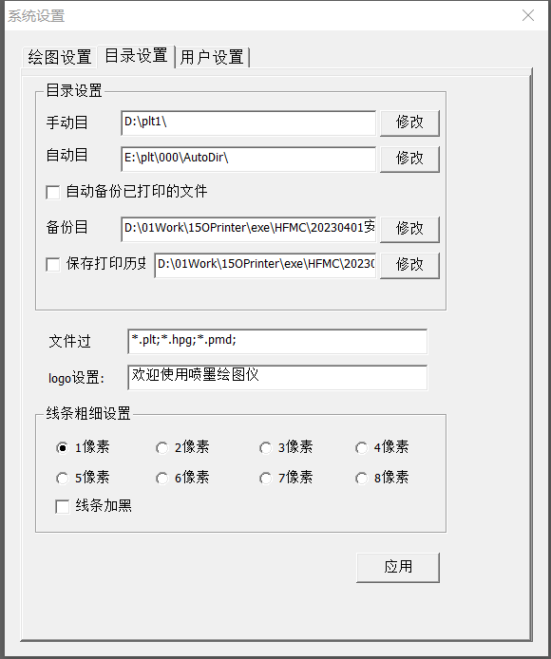
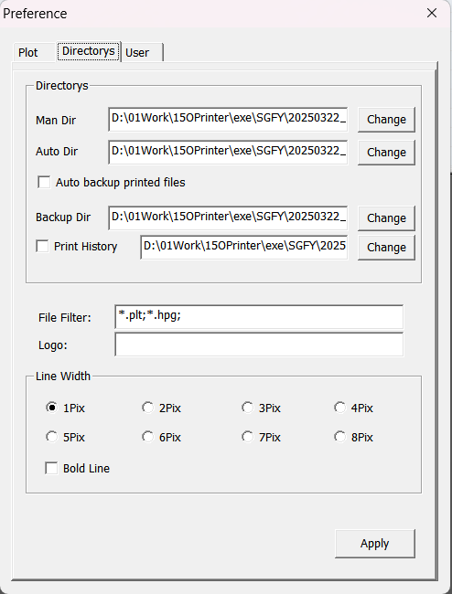
（图5.2）(Figure 5.2)
目录设置如图5.2所示，具体参数含义如下The directory Settings are shown in Figure 5.2, and the specific parameter meanings are as follows
序号Serial number | 参数名称Parameter name | 含义Meaning
1 | 手动目录Manual directory | 手动添加时默认打开的目录。The directory that is opened by default when added manually.
2 | 自动目录Automatic directory | 自动打印模式系统默认的读取目录。The automatic print mode is the default reading directory of the system.
3 | 自动备份已打印的文件Automatically back up the printed files | 自动备份已打印的文件。Automatically back up the printed files.
4 | 备份目录Backup directory | 自动备份开启时，用于存放备份文件的目录。The directory used to store backup files when automatic backup is enabled.
5 | 保存打印历史Save the printing history | 保存打印历史及用于存放历史文件的目录。Save the print history and the directory used to store historical files.
6 | 文件过滤File filtering | 限制打开文件时的文件类型。Restrict the file type when opening the file.
7 | logo设置logo Settings | 用于打印图纸时的自定义文字LOGO。A custom text LOGO used for printing drawings.
8 | 线条粗细设置Set the thickness of the lines | 设置打印线条的粗细。Set the thickness of the printing lines.
9 | 线条加黑Blacken the lines | 设置打印线条加黑。Set the print lines to be blackened.

5.3 用户设置（User Settings）
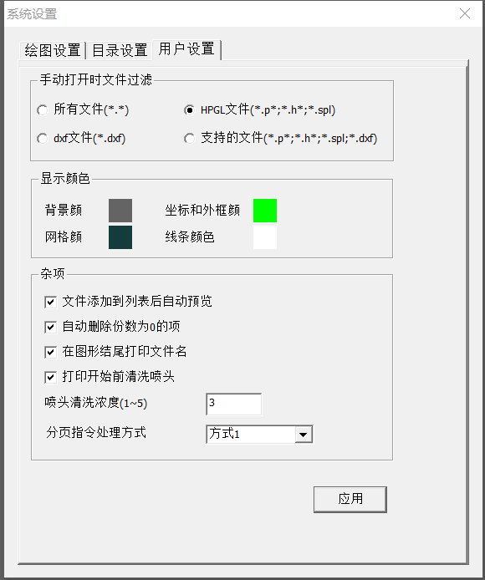
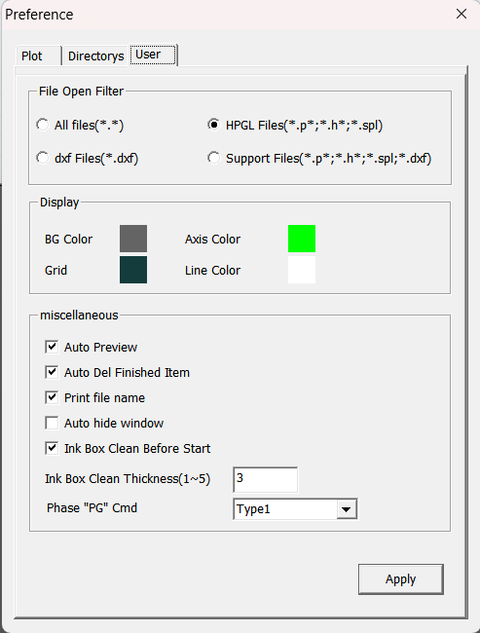
（图5.3）(Figure 5.3)
用户设置如图5.3所示，具体参数含义如下The user Settings are shown in Figure 5.3. The specific parameter meanings are as follows
序号Serial number | 参数名称Parameter name | 含义Meaning
1 | 手动打开时文件过滤File filtering when opened manually | 手动打开时文件过滤。File filtering when opened manually.
2 | 背景颜色Background color | 点选颜色方块可更换背景颜色。Click on the color square to change the background color.
3 | 坐标和外框颜色Coordinates and frame color | 点选颜色方块可更换坐标和外框颜色。Click on the color box to change the coordinates and frame color.
4 | 网格颜色Grid color | 点选颜色方块可更换网格颜色。Click on the color square to change the grid color.
5 | 线条颜色Line color | 点选颜色方块可更换线条颜色。Click on the color square to change the line color.
6 | 文件添加到列表后自动预览The file is automatically previewed after being added to the list | 文件添加到列表后自动预览。The file is automatically previewed after being added to the list.
7 | 自动删除份数为0的项Automatically delete items with a copy count of 0 | 自动删除份数为0的项。Automatically delete items with a copy count of 0.
8 | 在图形结尾打印文件名Print the file name at the end of the graphic | 在图形结尾打印文件名。Print the file name at the end of the graphic.
9 | 打印开始前清洗喷头Clean the nozzle before the printing starts | 打印开始前清洗喷头。Clean the nozzle before the printing starts.
10 | 喷头清洗浓度（1-5）Nozzle cleaning concentration (1-5) | 控制清洗喷头黑条的宽度。Control the width of the black strip of the cleaning nozzle.
11 | 分页指令处理方式Pagination instruction processing method | 用于兼容不同CAD输出的plt的分页指令。Paging instructions for PLTS that are compatible with different CAD outputs.

6 机器设置（Machine Settings）
点击图标或菜单栏选择“机器参数”会弹出机器设置界面。机器设置界面如下图所示。
Clicking the icon or selecting "Machine Parameters" from the menu bar will pop up the machine Settings interface. The machine Settings interface is shown in the following figure.
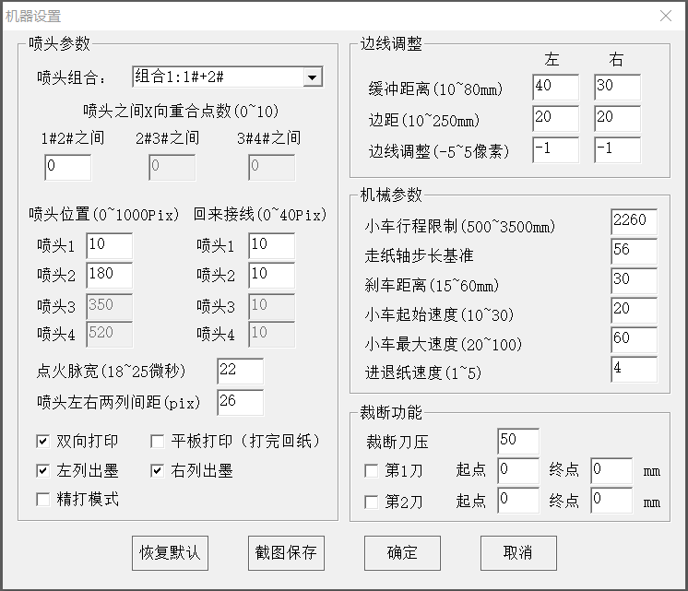
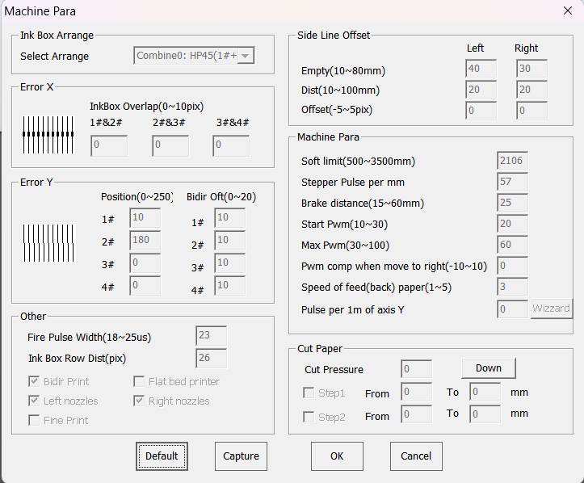
（图6.1）(Figure 6.1)

6.1 喷头设置（Nozzle setting）
序号Serial number | 参数名称Parameter name | 含义Meaning
1 | 喷头组合Nozzle combination | 选择使用哪几个喷头Choose which nozzles to use
2 | 喷头之间重合点数1#2#The number of overlappingpoints between the nozzles is 1# and 2# | 用于调整打印时，进退纸方向，墨盒之间重叠的像素。It is used to adjust the direction of paper entry and exit and the overlapping pixels between ink cartridges during printing.
3 | 喷头之间重合点数2#3#The number of overlapping points between the nozzles is 2# and 3#
4 | 喷头之间重合点数3#4#The number of overlapping points between the nozzles is 3# and 4#
5 | 喷头位置-喷头1Nozzle position - Nozzle 1 | 用于调整打印时左右方向几个墨盒喷出的线条的对齐。It is used to adjust the alignment of the lines ejected by several ink cartridges in the left and right directions during printing.
6 | 喷头位置-喷头2Nozzle position - Nozzle 2
7 | 喷头位置-喷头3Nozzle position - Nozzle 3
8 | 喷头位置-喷头4Nozzle position - Nozzle 4
9 | 回来接线-喷头1Return wiring - Nozzle 1 | 用于调整向左打印和向右打印时，线条的对齐。It is used to adjust the alignment of lines when printing to the left and to the right.
10 | 回来接线-喷头2Return wiring - Nozzle 2
11 | 回来接线-喷头3Return wiring - Nozzle 3
12 | 回来接线-喷头4Return wiring - Nozzle 4
13 | 点火脉宽Ignition pulse width | 和墨水材质有关系，一般来说墨水材质沸点低，此参数就需要调小，否则增大。一般情况保持默认值23即可。It is related to the ink material. Generally speaking, the boiling point of the ink material is low, so this parameter needs to be reduced; otherwise, it should be increased. Under normal circumstances, keeping the default value of 23 is sufficient.
14 | 喷头左右两边间距The spacing between the left and right sides of the nozzle | HP45墨盒，左右两列物理间距大约4.1mm，这个参数用于调整左右两列喷出的线条的相对位置，用于让两列喷出的线条对齐。The physical distance between the left and right columns of the HP45 ink cartridge is approximately 4.1mm. This parameter is used to adjust the relative position of the lines ejected from the left and right columns, so as to align the lines ejected from the two columns.
15 | 双向打印Bidirectional printing | 勾选此选项后，向左移动和向右移动都会出墨水。不勾选，则只有向左打印时出墨。After checking this option, both moving left and right will result in ink. If not checked, ink will only come out when printing to the left.
16 | 平板打印（打完回纸）Flatbed printing (return paper after printing) | 特殊应用时用到。平台式打印，打印完成后，打印横梁会回到起始位置。Used in special applications. Platform printing. After the printing is completed, the printing crossbeam will return to the starting position.
17 | 左列出墨The ink on the left is listed. | 一般两个都要勾选，打印时两列都出墨。如果只勾选一个，打印时，墨盒只有勾选的列出墨。Generally, both should be checked. When printing, ink will come out of both columns. If only one is selected, when printing, only the selected ink will be listed on the ink cartridge.
18 | 右列出墨The ink listed on the right
19 | 精打模式 Mode | 每次打印，往前送纸只前进一半的距离，相当于双pass模式。主要用于解决墨盒有堵孔的情况。Each time you print, the forward feeding paper only moves half the distance, which is equivalent to a double-pass mode. It is mainly used to solve the problem of clogged holes in ink cartridges.

6.2 边线调整（Edge line adjustment）
序号Serial number | 参数名称Parameter name | 含义Meaning
1 | 缓冲距离-左Buffer distance - left | 打印时，墨车左边的停车点和打印线条之间的距离。The distance between the parking point on the left side of the ink cart and the printing line when printing.
2 | 缓冲距离-右Buffer distance - right | 打印时，墨车右边的停车点和打印线条之间的距离。The distance between the parking point on the right side of the ink cart and the printing line when printing.
3 | 边距-左Margin - left | 用于补偿皮带拉伸和两侧加减速导致的边线不齐。其中“左边距”和“左边线调整”需要配合使用，“右边距”和“右边线调整”需要配合使用。边线调整需要将中间线调齐后才能调整。  以右边为例，先将“右边线调整”参数设置成0，打印系统自带的竖线图，观察来回不齐的范围，这个范围就是右边距。再观察最右边的竖线错位几个像素，将错位的距离填入右边线调整参数即可。It is used to compensate for the uneven edge lines caused by belt stretching and acceleration and deceleration on both sides. Among them, "left margin" and "left line adjustment" need to be used in combination, and "right margin" and "right line adjustment" also need to be used in combination. The edge line adjustment can only be made after the middle line is adjusted properly.  Take the right side as an example. First, set the "Right Line Adjustment" parameter to 0, print the vertical line chart that comes with the system, and observe the range of unevenness. This range is the right distance. Observe how many pixels the vertical line on the far right is misaligned, and fill in the misalignment distance into the adjustment parameter of the right line.
4 | 边距-右Margin - right
5 | 边线调整-左Sideline adjustment - left
6 | 边线调整-右Edge line adjustment - right

6.3 机械参数（Mechanical parameters）
序号Serial number | 参数名称Parameter name | 含义Meaning
1 | 小车行程限制Travel limit of the car | 防止撞车的软件保护长度。The length of software protection for preventing crashes.
2 | 走纸轴步长基准Paper shaft step size reference | 进退纸每毫米需要的脉冲数，用于调整每打印一段，进纸的距离。The number of pulses required for each millimeter of paper feeding and retraction is used to adjust the distance of paper feeding for each section printed.
3 | 刹车距离Braking distance | 用于调整小车停止位置的准确性（可配合状态栏的小车位置来调整）Used to adjust the accuracy of the car's stop position (can be adjusted in conjunction with the car's position in the status bar)
4 | 小车起始速度The initial speed of the car | 小车起步的速度（也是复位找原点的速度）The speed at which the car starts (also the speed at which it resets and finds the origin)
5 | 小车最大速度Maximum speed of the car | 小车打印加速完成的速度。The speed at which the car's printing acceleration is completed.
6 | 进退纸速度Paper feeding and retraction speed | 进退纸的速度。The speed of advancing and retreating the paper.

6.4 裁断功能（Discretion function）
序号Serial number | 参数名称Parameter name | 含义Parameter name
1 | 裁断刀压Cutting knife pressure | 启用裁纸功能后，裁断的刀压。After enabling the paper cutting function, the pressure of the cutting knife.
2 | 第1刀The first cut | 这几个参数配合，可以设定裁断动作可以设定成1刀裁断和2刀裁断。These parameters can be combined to set the cutting action, which can be set as 1-cut or 2-cut.
3 | 第1刀-起点Cut 1 - Starting point
4 | 第1刀-终点Cut 1 - Finish line
5 | 第2刀The second cut
6 | 第2刀-起点The second cut - starting point
7 | 第2刀-终点The second cut - Finish line

